From: | Sly, Darcy M <Darcy.Sly@CVSHealth.com>
Sent on: | Monday, July 11, 2022 5:25:44 PM
To: | Sly, Darcy M <Darcy.Sly@CVSHealth.com>; Addanki, Madhuri <Madhuri.Addanki@CVSHealth.com>
Subject: | 7/8 MYP Release Notification - Easy Transfers Team

Easy Transfers’ Release Communication
7/8 iOS Release – PI2
Easy Transfers is a full-stack web team, building solutions for Rx Transfers and Retail Onboarding

External Rx Transfers (Retail)

Please see 6/28 release notes, below, for full details on the new UX
- The new External Transfers (“X-TRx”) experience is live at 15% on web, mobile web and iOS app
    - 85% of users are still experiencing the old UX
- KPIs for the new UX are promising, with a strong increase in successfully submitted X-TRx requests:
    - Old UX completion rate on 7/10 (all platforms): 48.7%
    - New UX completion rate on 7/10 (all platforms): 61.8%

Completion Rate by Digital Platform for 7/10 (yesterday)
Because the new UX went live so recently, day-by-day data is a better representation of performance than week-over-week
Platform | Old UX | New UX
iOS | *46.7% | 61.8%
Web | 59.3% | 66.7%
Mobile Web | 45.3% | 61.1%
*Includes Android, due to reporting limitations

Release Plan
6/28 | 15% web/mWeb
7/7 | 15% of App users
7/12 | 50% of all users
BY END OF JULY | 100% of users

- New UX completion rates have been higher than old UX since the 6/28
  - Easy Transfers Team and MYP train will proceed with the planned release schedule

Please feel free to contact me directly with any clarifying questions,
And thanks again to the CRM train and MYP’s Easy Transfers engineers and MYP PO @Addanki, Madhuri for a successful product launch!

These enhancements have been coded and tested as part of the past iteration, and support team-committed features & objectives. For specific user stories in this iteration or release, you may check in Rally. Please feel free to reach out to me if you have any questions, comments, or concerns about the released stories.

Darcy Sly | Sr. Product Manager, Digital Pharmacy
401-477-6260
1700 Highland Corporate Drive, Cumberland, RI 02864

CONFIDENTIALITY NOTICE: This communication and any attachments may contain confidential and/or privileged information for the use of the designated recipients named above. If you are not the intended recipient, you are hereby notified that you have received this communication in error and that any review, disclosure, dissemination, distribution or copying of it or its contents is prohibited. If you have received this communication in error, please notify the sender immediately by email or telephone and destroy all copies of this communication and any attachments.

From: Sly, Darcy M
Sent: Wednesday, June 29, 2022 2:39 PM
To: Sly, Darcy M <Darcy.Sly@CVSHealth.com>
Subject: 6/28 MYP Release Notification - Easy Transfers Team

Easy Transfers’ Release Communication
6/28 Release – PI2
Easy Transfers is a full-stack web team, building solutions for Rx Transfers and Retail Onboarding

External Rx Transfers - New UX is live at 15% for web/mweb

Special thanks to the CRM train—their PMs, POs and UX designed this improved UX before the Epic came to the MYP train for completion!

Objective: Increase script growth by improving External Rx transfer process for both Digital users and Operations

• Digitize the paper fax intake process to RxConnect

• Digital UX should auto-fill data whenever possible

• Provide users with status updates on their TRx request

Release Schedule
6/28 | 15% web/mWeb
7/7 | 15% of App users
7/12 | 50% of all users
By end of July | 100% of users

Business Need: CVS misses new customer opportunities due to unaddressed transfer requests
- CVS spends $1MM/year on labor to address faxed transfer requests
  - New process simplifies ops’ level of effort by digitizing TRx requests into RxConnect Queues
- 55% of external transfer requests are reviewed by pharmacy ops à ~45% are not addressed
  - Completing more external TRx requests can result in an additional $5MM in Rxs/year
- ~50% of visitors to Digital’s legacy TRx UX successfully submit a transfer request
  - New UX will decrease drop-off rate
- Transfers is a top ETMM opportunity

Release Monitoring:
- Operations - Track completion rate of transfer requests in RxConnect that yield a new Rx
  - SLA 45 minutes to begin working Transfer requests in RxConnect Triage queue
  - Successful transfers yield a net new Rx within 14 days of initial request
- Digital UX – Track visits, completion and drop-off rates across UX
- CSAT – Monitor customer feedback through surveys and QM (TRx is a top 10 ETMM opportunity)

Digital UX Details: Simplifies the External Transfer Request UX, and provides transparency on status of each transfer request
- Smart search fields decrease need for manual data entry from users
- New “transfer status” feature, and corresponding transfer status page, lets users track the status of their transfer requests
  - New automated email notifications also keep users informed about the status of transfer requests
- External TRx UX is available to guests, unauthenticated and authenticated users
- Digital is just the first step in the TRx process:
  - Once a Digital user submits a transfer request, pharmacy operations receives the request in an RxConnect queue
  - Ops must begin working on the transfer request within 45 minutes, but completion may take up to two weeks, due to data delays from competitors and/or medical providers

Digital UI:
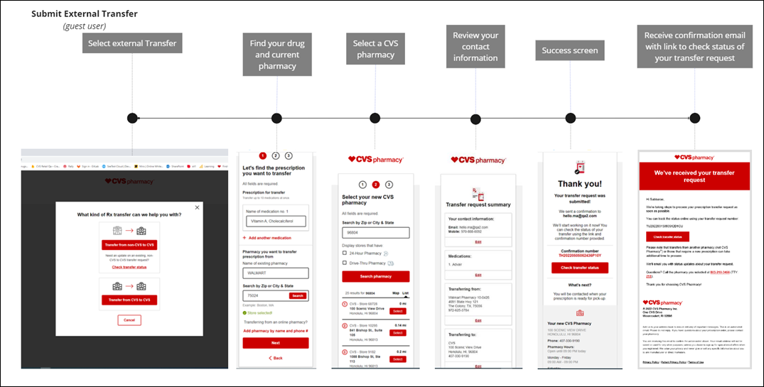

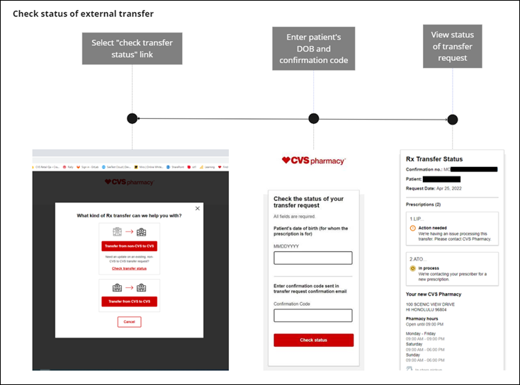

These enhancements have been coded and tested as part of the past iteration, and support team-committed features & objectives. For specific user stories in this iteration or release, you may check in Rally. Please feel free to reach out to me if you have any questions, comments, or concerns about the released stories.

Darcy Sly | Sr. Product Manager, Digital Pharmacy
401-477-6260
1700 Highland Corporate Drive, Cumberland, RI 02864

CONFIDENTIALITY NOTICE: This communication and any attachments may contain confidential and/or privileged information for the use of the designated recipients named above. If you are not the intended recipient, you are hereby notified that you have received this communication in error and that any review, disclosure, dissemination, distribution or copying of it or its contents is prohibited. If you have received this communication in error, please notify the sender immediately by email or telephone and destroy all copies of this communication and any attachments.

